English 181 Riccomini
Individual Effort Rating for Team Member

Name _Yang Li________________________________________ Date __11/18/16____

Course __ENGL181_________________

Please rate the performance of your current team members as indicated below.
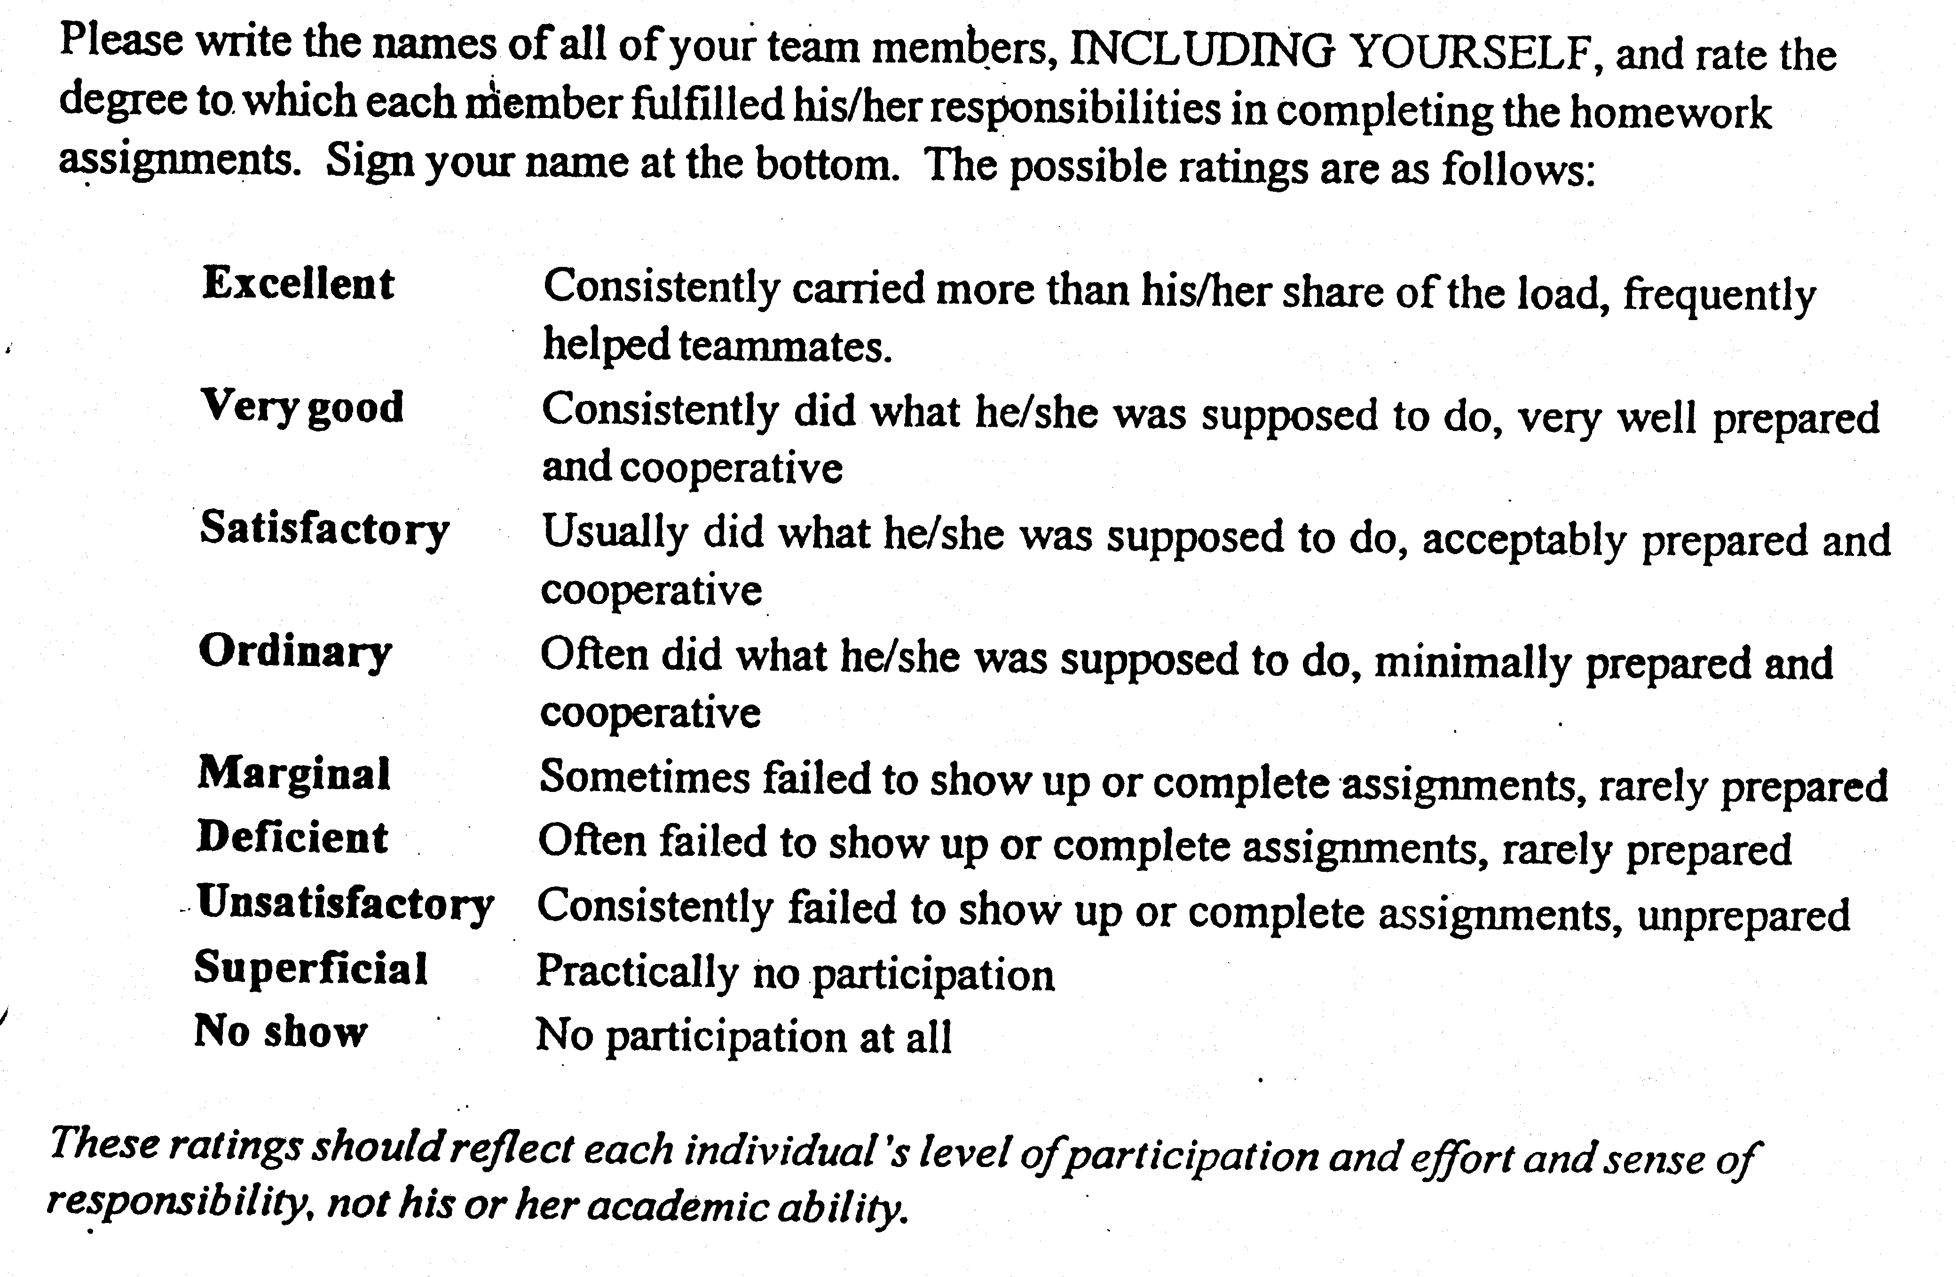
Name of Team Member | Your Rating | Numerical Score (Instructor’s Use Only)
Abe Millan | Very Good
Blake Tsuzaki | Very Good
Yang Li | Very Good

Don’t forget to include yourself in the rating.

Signature
Due at next class meeting. Must be signed. Thanks!

